**NORTHERN MIDDLE SCHOOL**

**BEGINNER PIANO CLASS**

**MRS. OMETZ MR. MCCARTNEY**

**Email:** [**aometz@northernyork.org**](mailto:aometz@northernyork.org) **Email: cmccartney@northernyork.org**

Welcome to Beginner Piano/Keyboard Class!!! This semester you will learn how to read music, play chords and scales, learn the keys on the piano and have fun learning to play the piano/keyboard. The requirements for the class are listed below:

1. Piano students will be assigned lessons from a piano method book *(Alfred’s All in One Course-Piano)* that will be provided and will be yours to keep at the conclusion of the class. Folders, headphones and paper will be provided unless students want to bring their own. **Students must have a pencil and piano book every day!**

2. You will be given an individual assignment that will be recorded in a teacher notebook. This assignment will help you master the skills that you will need to have in order to be able to play the piano/keyboard. On an assigned playing day, you will play for a grade. This grade is based on your individual progress and the mastery of the assigned lesson. IT IS YOUR RESPONSIBILITY TO BE PREPARED FOR THIS PLAYING TEST. **Points will be deducted for poor or non preparation.**

At each playing grade, you will be assessed in the following areas: Note Accuracy, Rhythmic Accuracy/Tempo, Technique/Musicality, and Posture.

3. Keyboard students will be required to read standard musical notation and learn musical terms and symbols used in playing and performing.

1. During class time, if it is not a day for you to play for a grade, you are EXPECTED to use that time as a PRACTICE TIME. (You can also practice writing musical notation, reading notes, practicing rhythms, building chords etc.) The more you put into this course, the more you’re going to get out of it.
2. Keyboards are provided for students in the classroom.  It is helpful if the student has access to a piano or keyboard for practice on outside of school but it is not mandatory. The more you practice, the better you will become.
3. Students will be using the internet in class to visit websites that enhance music theory knowledge. The Acceptable Use Policy must be signed before students are permitted to use the internet. Students will be using music software to develop music reading/writing skills. Worksheets will also be provided to assist students in this aspect.
4. Students can earn up to 10 points per class for their participation/practice/preparation (the 3 P’s). Points will be deducted for poor or non- participation; non-cognitive practice and for non-preparedness (no book). Gum chewing/food/drinks are not permitted in piano class.

20% will be deducted for assignments that are one day late, and 50% two days late. After two days students will receive a zero unless another agreement has occurred due to sickness or other extenuating circumstances. Students have the same number of days to make up work/turn

in assignments as the amount of days they were absent from school.

Playing grades are based on Note Accuracy, Rhythmic Accuracy/Tempo, Technique/Musicality, and Posture; and are scored Non-Proficient (60-60%), Partially Proficient (70-75%), Proficient (76-89%), or Advanced (90-100%). All students should strive to be at the Proficient or Advanced level (or at 76% and above).

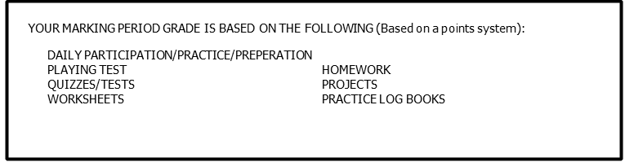

# Classroom Expectations:

* **Be Prepared**
* **Make an Honest Effort**
* **Act Responsibly and Respectfully**
* **Respect Each Individual’s Right to Learn**

# COURSE OBJECTIVES

The student will:

1. Develop and refine playing skills through performance on the keyboard.

2. Increase musical understanding and knowledge of musical terms, keyboard literature and its historical background.

3. Develop individual playing styles on the keyboard.

4. Develop through listening and performing, an appreciation of music as an art form.

5. Enhance playing skills and knowledge on the keyboard.

6. Develop a lifetime appreciation and/or participation of music.

**Please have a parent/guardian sign, you sign and date, and return this page to your teacher by the 5th school day of the marking period.**

I, _________________________________________, have read the course outline for

(Student’s name)

Piano Class and understand what is expected of me with regards to classroom policies, grading, and performance expectations; and am willing to comply with these policies.

Signature of Student _______________________________________________________

Signature of Parent/Guardian ________________________________________________

Date _______________________

I understand that if the book is lost the family will need to replace it for a $20 fee.

Parent initials: _______